**General Discription:**

Data Mapping

|  |  |  |  |
| --- | --- | --- | --- |
| Discrete input (1byte) |  | Coil output(1 byte) |  |
| Bit |  | Bit |  |
| 0 | Input Signal 1 | 0 | Output Signal 1 |
| 1 | Input Signal 2 | 1 | Output Signal 2 |
| 2 | Input Signal 3 | 2 | Output Signal 3 |
| 3 | Input Signal 4 | 3 | Output Signal 4 |
| 4 | Input Signal 5 | 4 | Output Signal 5 |
| 5 | Input Signal 6 | 5 | Output Signal 6 |
| 6 | Input Signal 7 | 6 | Output Signal 7 |
| 7 | Input Signal 8 | 7 | Output Signal 8 |
| Input Register (4 bytes) |  | Output Register (4 bytes) |  |
| 1 | Analog input 1 | 1 | Analog output 1 |
| 2 | Analog input 2 | 2 | Analog output 2 |
| 3 | Analog input 3 | 3 | Analog output 3 |
| 4 | Analog input 4 | 4 | Analog output 4 |

**Protocol description:**

**Read digital register (1 byte)**

Message Request:

|  |  |  |
| --- | --- | --- |
| Slave Address | Function Code | CRC |
| 1 byte | 0x01 | 2 bytes |

Message response:

|  |  |  |  |
| --- | --- | --- | --- |
| Slave Address | Function Code | Data | CRC check |
| 1 byte | 1 byte | 1 bytes | 2 bytes |

Example:

|  |  |  |
| --- | --- | --- |
|  | Request | Response |
| Slave adress | 0x10 | 0x10 |
| Function code | 0x01 | 0x01 |
| Data | - | 0x05 |
| CRC 1 | 0xCD | 0xB1 |
| CRC 2 | 0xB0 | 0x96 |

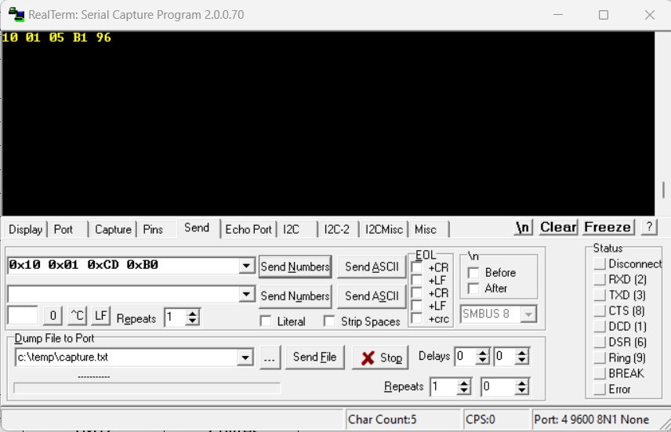

**Read holding register (n bytes)**

Message Request:

|  |  |  |
| --- | --- | --- |
| Slave Address | Function Code | CRC |
| 1 byte | 0x02 | 2 bytes |

Message response:

|  |  |  |  |
| --- | --- | --- | --- |
| Slave Address | Function Code | Data | CRC check |
| 1 byte | 1 byte | 4 bytes | 2 bytes |

Example:

|  |  |  |
| --- | --- | --- |
|  | Request | Response |
| Slave adress | 0x10 | 0x10 |
| Function code | 0x02 | 0x02 |
| Data | - | 0x01 0x05 0x07 0xCA |
| CRC 1 | 0x8D | 0xE8 |
| CRC 2 | 0xB1 | 0xD1 |

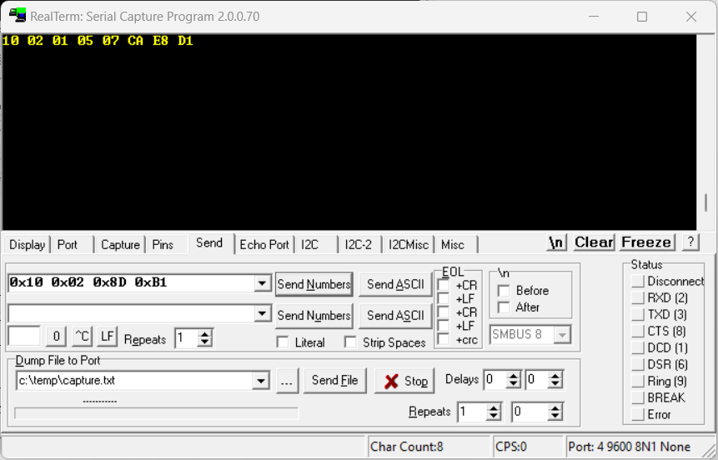

**Write Coil**

Message Request:

|  |  |  |  |
| --- | --- | --- | --- |
| Slave Address | Function Code | Data | CRC |
| 1 byte | 0x03 | 1 byte | 2 bytes |

Message response:

|  |  |  |  |
| --- | --- | --- | --- |
| Slave Address | Function Code | Data | CRC check |
| 1 byte | 1 byte | 1 bytes | 2 bytes |

Example:

|  |  |  |
| --- | --- | --- |
|  | Request | Response |
| Slave adress | 0x10 | 0x10 |
| Function code | 0x03 | 0x03 |
| Data | - | 0x01 |
| CRC 1 | 0xB1 | 0xB1 |
| CRC 2 | 0x35 | 0x35 |

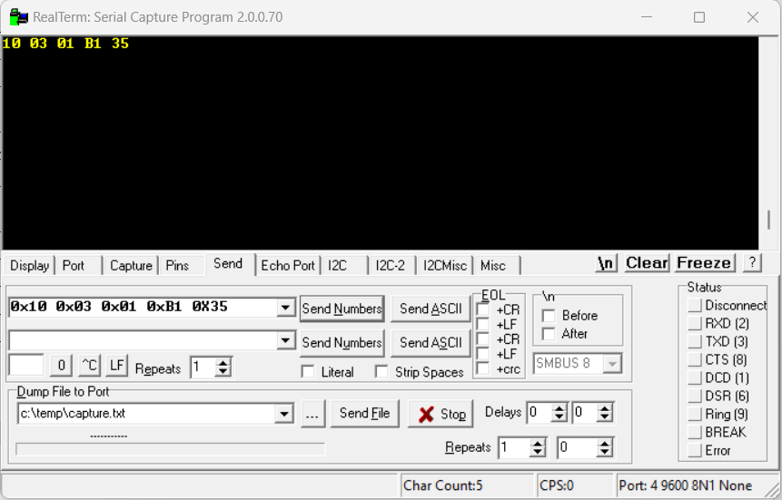

**Write Holding Register**

Message Request:

|  |  |  |  |
| --- | --- | --- | --- |
| Slave Address | Function Code | Data | CRC |
| 1 byte | 0x04 | 4 byte | 2 bytes |

Message response:

|  |  |  |  |
| --- | --- | --- | --- |
| Slave Address | Function Code | Data | CRC check |
| 1 byte | 1 byte | 4 bytes | 2 bytes |

Example:

|  |  |  |
| --- | --- | --- |
|  | Request | Response |
| Slave adress | 0x10 | 0x10 |
| Function code | 0x04 | 0x04 |
| Data | 0x01 0x01 0x01 0x01 | 0x01 0x01 0x01 0x01 |
| CRC 1 | 0x63 | 0x63 |
| CRC 2 | 0x27 | 0x27 |

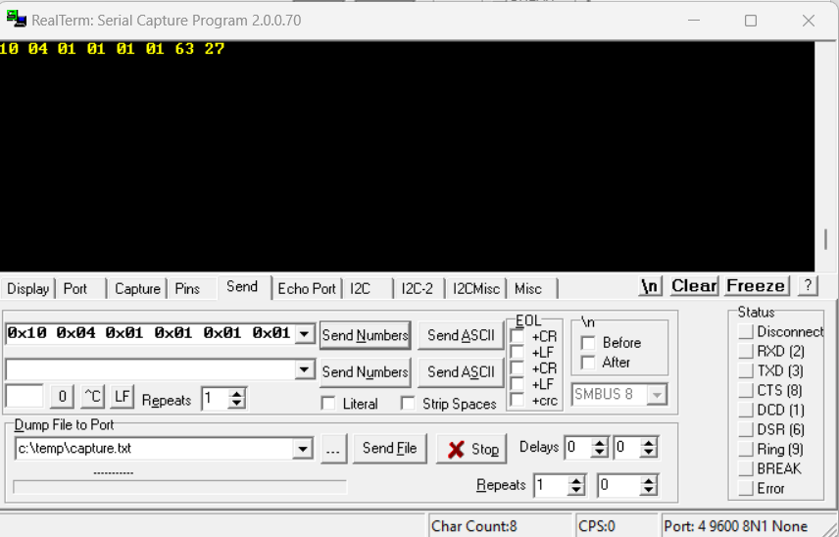

**Error**

Message Request:

|  |  |  |
| --- | --- | --- |
| Slave Address | Function Code | CRC |
| 1 byte |  | 2 bytes |

Message response:

Error code: 0x00

Exception Error code:

+ 0x00 – *CRC mismatch*

+ 0x01 – *Invalid Function Code*

|  |  |  |  |
| --- | --- | --- | --- |
| Slave Address | Error code | Exception Code | CRC check |
| 1 byte | 0x00 | 0x01 | 2 bytes |

Example:

CRC mismatch:

|  |  |  |
| --- | --- | --- |
|  | Request | Response |
| Slave adress | 0x10 | 0x10 |
| Function code | 0x02 | 0x00 |
| Data | - | 0x00 |
| CRC 1 | 0x8D | 0x70 |
| CRC 2 | 0xB0 | 0x05 |

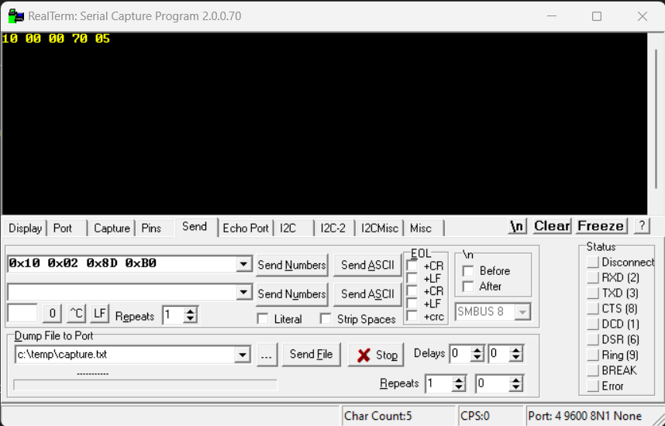

Invalid Function Code:

|  |  |  |
| --- | --- | --- |
|  | Request | Response |
| Slave adress | 0x10 | 0x10 |
| Function code | 0x05 | 0x00 |
| Data | - | 0x01 |
| CRC 1 | 0xCC | 0xB1 |
| CRC 2 | 0x73 | 0xC5 |

